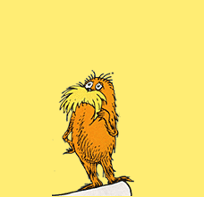
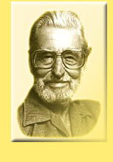

Dr. Seuss 1904 - 1991

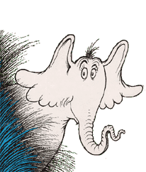
In 1925, he enrolled at Oxford University to become an English Professor, although he quit a few years later, Theodor Geisel, aka Dr. Seuss, continues to be one of the greatest educators we will ever know. Yes, books like the “Cat in the Hat” are great for early readers, but beyond that, he wrote a number of books that can be used to spark debates in your Social Studies classroom. Here are some examples:

Horton Hears a Who –
- based on Japanese occupation after WWII.
- Geisel attempts to portray the Japanese in a new light in the post-war era.
- theme – should our differences determine our worth?
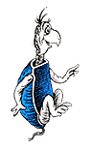

Yertle the Turtle –

a story about Fascism and Totalitarianism

Yertle is actually based on Hitler (in the original drawings of Yertle, he even had a Hitler-esque moustache!)

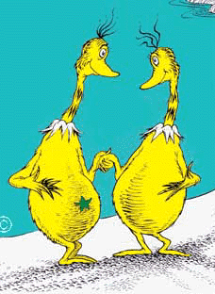
The Sneeches –
- displays how trivial and ridiculous racism and prejudice can be.
- This project was nearly scraped because Geisel thought he was being too insensitive using the star a symbol considering the connotations related to Jews in Nazi Germany.

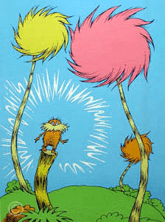
The Lorax –
- Pick an issue to discuss with this one… conservation and environmentalism, sustainable development, conspicuous consumption, or marketing and the consumer environment!
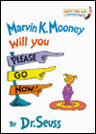
- Ends with a great message of empowerment – start a discussion about what they could do to improve the world.

Marvin K. Mooney Will You Please Go Now!
- written for Richard M. Nixon during Watergate.
- Seuss actually released a version of the story to the press that replaced “Marvin K. Mooney” with “Richard M. Nixon”. 9 days later, Nixon resigned.

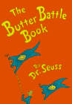
The Butter Battle Book –
- Geisel was 84 when he wrote this parody of the Cold War.
- mainly aimed at the rhetoric being used by the Reagan administration.
- themes to discuss – the Berlin Wall, the Arms Race, and mutual assured destruction.

